INSTRUCTION MANUAL FOR CENTRIFUGE DSC-200T
Lock
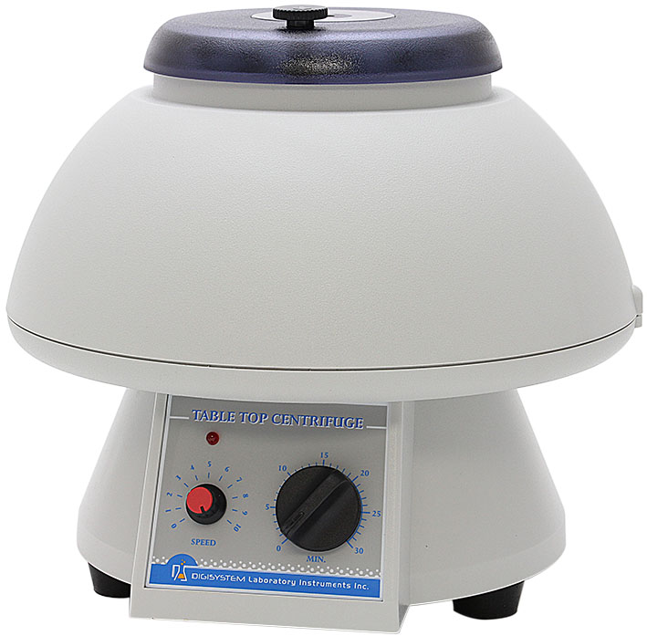
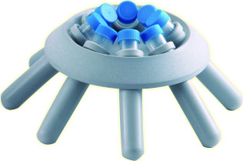
Lid

Rotor
Tube holder
Timer
Power indicator

Speed controller

Warnings:
* Do not open the lid before the centrifuge stops completely.
* Do not remove the centrifuge during operation.
* Do not put objects on the top of the lid.
* Do not disassemble the centrifuge by yourself. In the event of a malfunction, the centrifuge should be repaired by a qualified technician. Before repairing, turn off the power.

Steps:
1. Place the centrifuge on a flat surface. Plug the centrifuge into a properly grounded outlet which corresponds with the electrical requirements on the label back on machine.
2. Press and turn the ‘Lock’ ‘ left or right to open the ‘Lid’ of the centrifuge, then, place the tubes with specimen (each tube must be an equivalent in weight) into the ‘Tube holder’, and then insert them into the ‘Rotor’. If only one specimen is tested, you should put other empty tubes with water in equal weight together with ‘Tube holder’ into the Rotor for centrifugal.
3. Put the’ Lid’ down gently, and turn the ‘ Lock’ left or right to close the ‘Lid’.
4. Turn the ‘Timer’ over the required scale, then return the time calibration as required scale. (For instance, you need 5 minutes for centrifugal, but you need to wind to 7 or 8 minute scale at first, then return back to 5 minute scale.) Then, the ‘Power indicator’ lights up.
5. Adjust the’ Speed controller’ to the desired setting .
6. The centrifugal time reaches to the end, then a sound ‘DON’ to be heard.
7. After the ‘Rotor’ stops completely, open the ‘Lid’ and take out the specimen.
Notes:
During the operation, there are two methods ((1) and (2)) to stop the machine emergently.
(1) Open the’ Lid’, and then the safety switch device will cut off the power. The machine will stop in minutes.
(2) Turn the ‘TIMER’ counterclockwise to 0, and then you will hear the sound “DON”. The machine will stop in minutes.
Please note that you can open the ‘Lid’ only after the ‘Rotor’ stops completely.

Maintenance and care:
- Keep the centrifuge clean all the time. Cleaning can be done with a damp cloth. Avoid the use of solvents as they may damage the product housing, rotor.
- Check if the rotor is in the center. In case, the rotor is slanted. Stop using machine and contact the distributor for repair.
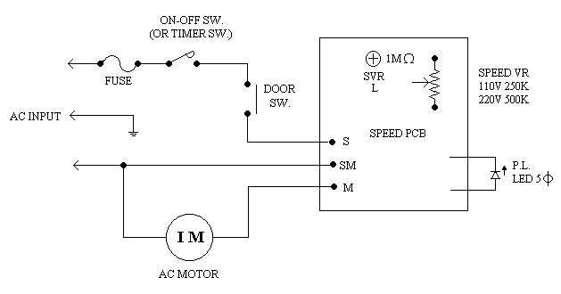
Circuit Diagram:

Service Manual

Troubleshooting Guide
Caution: Always disconnect the power cord before troubleshooting.
Trouble | Cause | Remedy
Motor is not working | Power code is not securely connected. | Reconnect it securely.
Motor is not working | Fuse is burnt. | Replace a fuse.
Motor is not working | Time switch is not set. | Turn the timer to a required scale.
Motor is not working | Lid is not closed well. | Open lid and close it again.
Motor is not working | The setting of micro switch is not proper or it is broken. | Contact your distributor for repair.
Motor is not working | The wiring of motor is not well. | Contact your distributor for repair.
LED power indicator can not light up | The wiring of PC board and LED is not well. | Contact your distributor for repair.
LED power indicator can not light up | The LED is broken. | Contact your distributor for repair.
Motor can’t stop | The time switch is not at zero. | Turn it to zero.
The power is not cut off when open the lid | The setting of micro switch is not proper. | Contact your distributor for repair.
Timer is not accurate | Timer is not set by the correct procedures. | Read the operation manual and set it again.
Timer is not accurate | Timer is broken. | Contact your distributor for repair.
The rotor is slanted | Motor mount is worn-out. | Contact your distributor for repair.

